CLOUD COMPUTING LAB: WEEK 7
PES1201802127
Siddharth K Rao

1.) Task 1: Setting up jenkins and using Docker

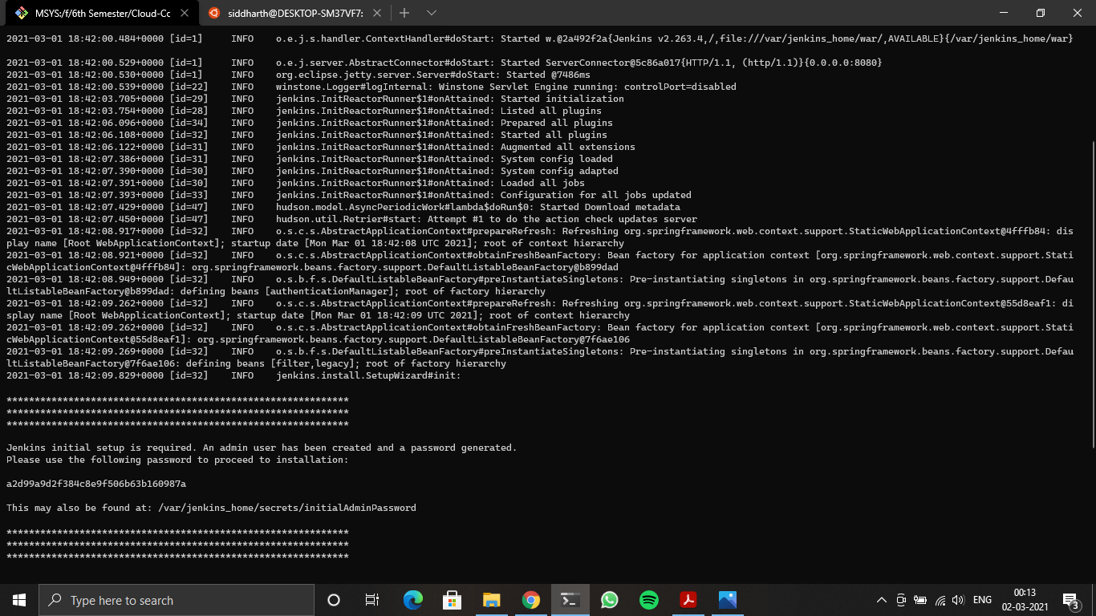
1A - Running Docker Container

2.) Task 2: Setting up a job in jenkins to connect to a repository and build C++ hello.cpp
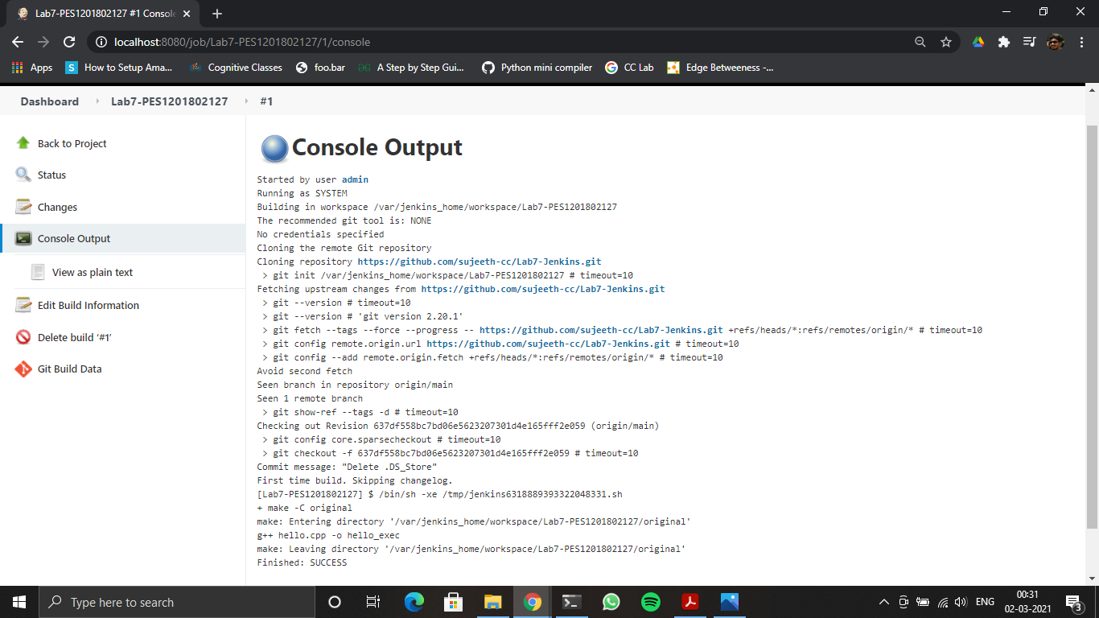
2A – Console Output after the build is successful

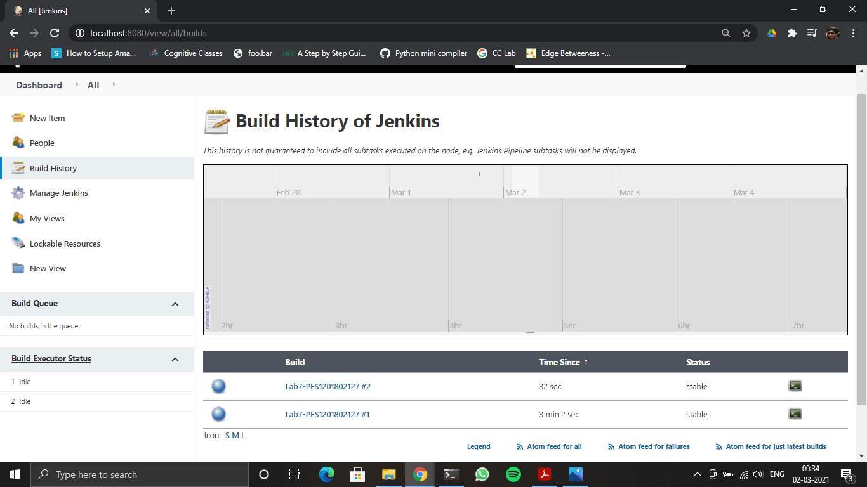
2B – Stable state of the task

3.) Task 3:

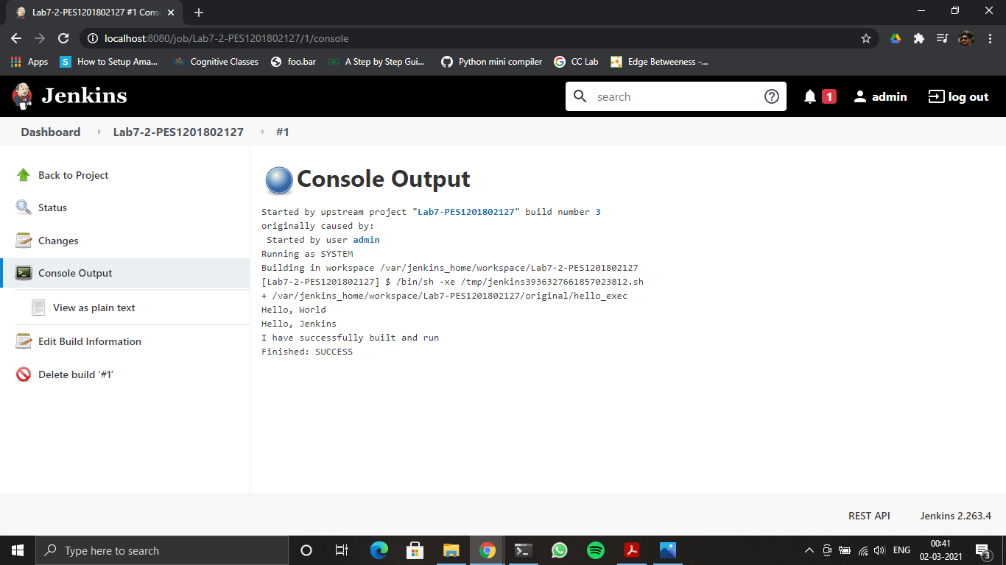
3A – Console Output of the second job

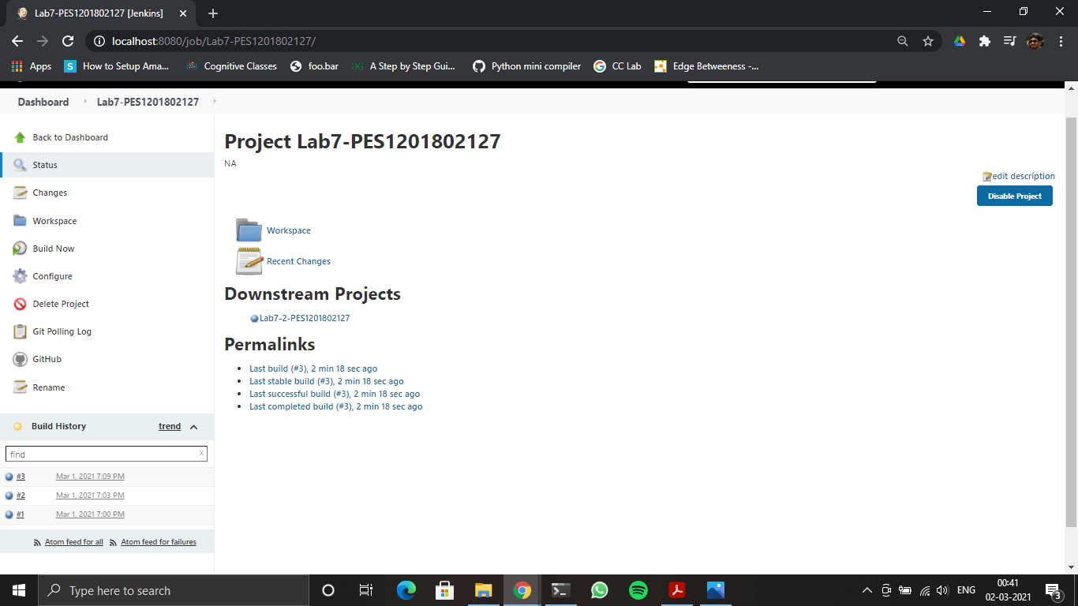
3B – Status page of the first job

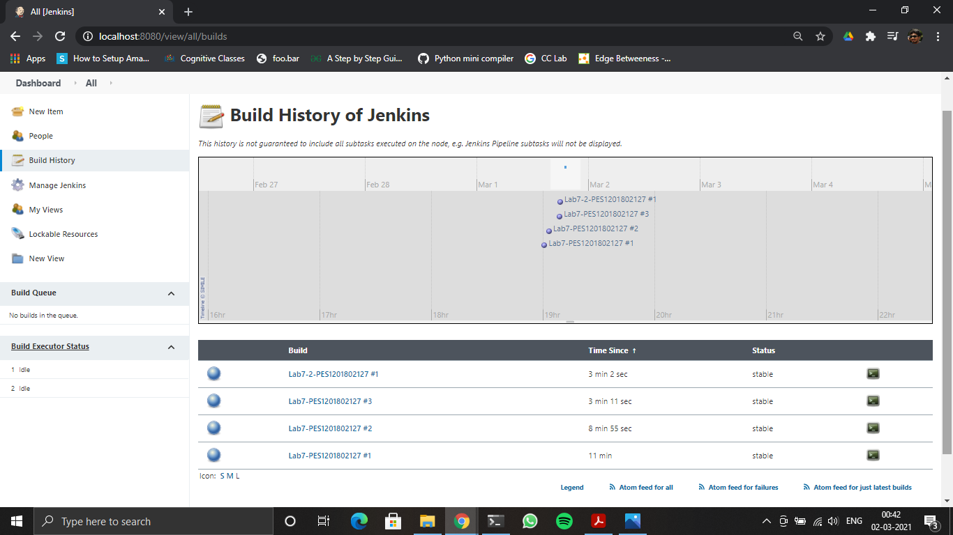
3C – Build History of Jenkins

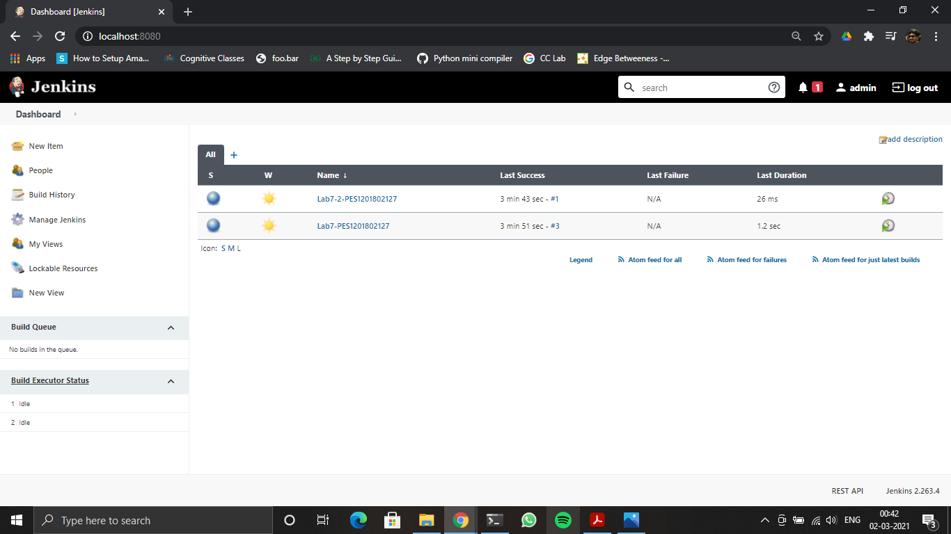
3D – Jenkins Dashboard

